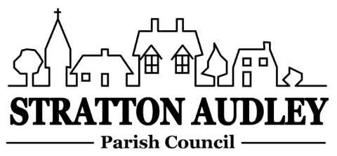
To Members of the Council: you are summoned to attend a meeting of Stratton Audley Parish Council on Wednesday 5th July 2017, in the Hunt Room of the Red Lion , Stratton Audley at 7.00pm
Members of the Public: you are invited to attend
AGENDA
- Apologies for absence – to receive apologies and to note reasons for absence
- Declarations of interest – to receive any declarations of interest from Councillors relating to items on the Agenda, in accordance with the Council’s Code of Conduct
- Public participation – to receive questions and comments from members of the public.
- To welcome PCSO Louise Beaumont Rural Policing team
- To welcome Ian Corkin –OCC and CDC
- To receive and approve the Minutes of the Parish Council Meeting held on Wednesday 7th June 2017
- Update on progress from the Minutes – Clerk/Chairman/Councillors will report on progress of outstanding items which do not require further decision – Facebook, Telephone box removal, road signs, parking by concrete blocks at quarry entrance,
- Finance
  - To receive the financial report – for information
  - To consider invoices for payment.
- Parish Matters not otherwise mentioned under section 5 above:
  - Rural Transport –any update
  - Use of Facebook
  - Playbus
  - Hunt re Hound route exercising and schedule
  - Speeding traffic on the Bicester Road/VAS purchase
  - Road Maintenance/curbs
  - Un-metalled footpaths and bridleways report
  - National Garden Scheme/best kept small village
- CLP update to include review of the open Garden/Scarecrow weekend,
- Planning –
Nothing at present
- Correspondence received –
- Reports from meetings – CDC’s Parish Liaison meeting on 21st June 2017
- Items for information or next Agenda only – all items for the next agenda to be submitted to the Clerk by 19th July 2017
- Date of next meeting – to confirm the date of the next meeting as Wednesday 2nd August 2017

Anne Davies, Clerk to the Council
6 Greystones Court, Kidlington Oxon OX51AR strattonaudley.parishclerk@gmail.com

